Case Studies and HOTS for Class III EVS
Chapter 1: Family and Friends
Case Study: A Day with Family
Ravi lives with his parents and grandparents. On Sundays, they all spend time together. His grandmother tells stories, his grandfather takes him to the park, and his parents play board games with him.
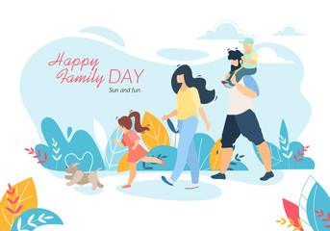
Q1. The type of family Ravi has-
a) Nuclear family
b) Joint family
c) Single-parent family
d) Extended family
Q2. How do Ravi and his family spend Sundays?
a) They stay in different rooms and watch TV
b) They spend time together doing different activities
c) They go to different places separately
d) They do not talk to each other
Q3. Who in Ravi’s family tells him stories?
a) His father
b) His mother
c) His Grand mother
d) His Grand father
Case 2: Neha’s Best Friend
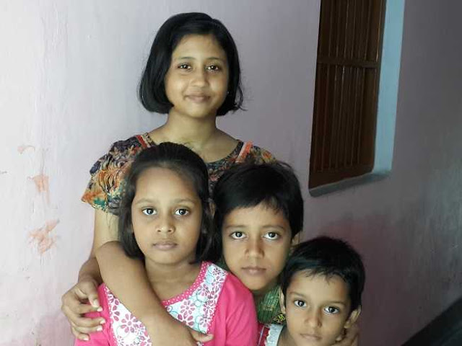
Neha and Riya are best friends. They study in the same class and sit together. Neha shares her lunch with Riya, and they help each other in studies. One day, Riya forgot her notebook, and Neha helped her by sharing hers.
Q4. What quality of Neha is shown in the story?
a) Kindness
b) Selfishness
c) Rudeness
d) Laziness
Q5. Why do you think Neha and Riya are good friends?
a) They fight every day
b) They never help each other
c) They share things and support each other
d) They do not talk to each other
Case 3: A Festival at Home

Case 3: Family Festivals
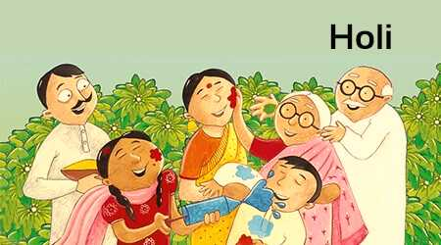
Family Festival Rohan’s family celebrates Diwali together. They clean their house, decorate it with lights, and make sweets. Rohan and his sister light diyas, while their parents prepare a feast. Everyone in the family enjoys the festival.
Q6. What festival is Rohan’s family celebrating?
a) Holi
b) Diwali
c) Eid
d) Christmas
Q7. How does Rohan’s family prepare for the festival?
a) They do nothing special
b) They go on a holiday
c) They clean the house and decorate it
d) They stay indoors without any celebration

Q8. What do Rohan and his sister do during the festival?
a) Light diyas
b) Go to school
c) Play video games
d) Sleep all day

HOTS Questions
1. State the importance of a joint family in our lives.
2. Why do we need friends in our lives?
3. If a new student joins your class, how can you make them feel like a friend?
4. If your friend is upset, what would you do to cheer them up?
5. Imagine a world where everyone in a family had the same role. What problems might arise?
6. Design a "Friendship Code" with three rules that every good friend should follow.
7. Do you think friends are as important as family? Why or why not?
8. What qualities make someone a good family member or friend?
____________________________

